**ARADE USER GUIDE**

**Input Data**



**Version 1.58 Jul 2021**

**Version History**

|  |  |  |  |
| --- | --- | --- | --- |
| **Version** | **Date** | **Author** | **Comments** |
| 1.28 | Sep 2020 | K.Wilson | Initial version |
| 1.29 | Sep 2020 | K.Wilson | Added Mud variations, FF profiles and Reaming Intervals |
| 1.44 | Dec 2020 | K.Wilson | Added Mud columns and Depth effects for Surge and Swab |
| 1.50 | Apr 2021 | K.Wilson | General review |
| 1.58 | Jul 2021 | K.Wilson | Additional search criteria for components |

Contents

Setting up a scenario 1

Copy tables from another Scenario 1

Well Path 2

Importing path data 4

Adding Tortuosity 5

String and Accessories 8

Hole Profile 12

Mud Variation 13

Mud program 13

Annulus Mud Weight Profile 14

Pipe Mud Weight Profile 14

Circulating profiles 15

Mud columns 16

Mud Depth Effects 18

Friction Factor Profile 19

Reaming Intervals 20

# Setting up a scenario

Part of the setup of a new scenario is to define the input data. Some of these are required and others are optional.

Data may be entered manually, item by item, with some tables allowing item values to be copied from a library.

Others allow data to be imported from a text file. If you have data in a spreadsheet, it can be exported as a tab delimited text file suitable for importing.

In many cases, you can also copy data from another scenario. This allows multiple scenarios over the same hole section to be generated quickly and easily for comparison.

A new scenario can also be based on a copy of an existing one, so only the changed data needs to be entered.

The basic input data sets are the Path, Hole and String tables. Additional tables can be used for more complex mud situations and Rock Mechanics and Measured data can be imported or entered for overlaying on plots.

All these tables can be accessed via options in the Scenario menu or by clicking buttons on the Scenario form.

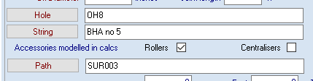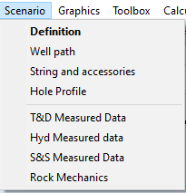

For general information on how to navigate table forms see the “Parade User Guide -User Interface” Document

## Copy tables from another Scenario

In many planning situations, multiple scenarios are created with alternate input data to determine the optimum combination. In order to facilitate this, scenarios can be created as a duplicate of an existing scenario and datasets can then be copied from a different scenario.

For example, you may be considering 2 well paths and 2 strings, create a scenario with path A and String A. Copy that and change the string to String B. Copy that and replace the path with Path B. Make another copy and change the string back to A. Label these scenarios with suffixes AA, AB, BB and BA.

This can be extended to include more than 2 choices and additional variations in hole profile, mud programs and so forth.

Most of the tables have a [Copy] button that facilitates this.

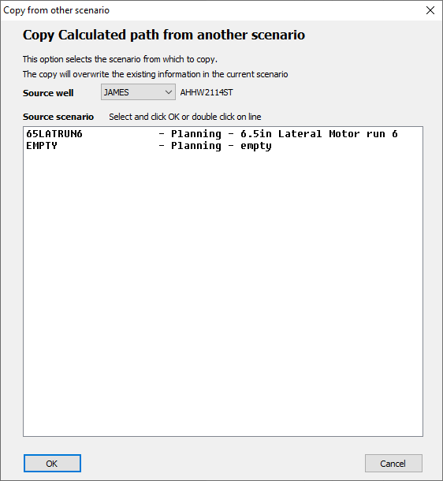

These dialogs are essentially the same with just the title line changed to indicate which data is being copied.

The Source well defaults to the current well and other scenarios for the well are displayed.

However, you can select a different well and copy from a scenario in that well. This may be useful if the same string combination is used in multiple wells.

# Well Path

Parade allows 3 well paths to be defined for each scenario. Each of these can be imported from a text file created by a 3rd party, either a path planning program or from actual measurements.

The **Planned path** is usually an ideal path, consisting of a series of straight sections and curved sections. It is not a realistic representation of an actual well path and is likely to underestimate the Torque and Drag.

The **Actual or Measured Path** is one based on a survey or MWD values of the actual well. For MWD this may have a very small increment between readings resulting in a very large file, which may slow down calculations and plotting.

The **Calculation Path** is the path that is used in the calculations and may be either directly imported, if the measure path is suitable, or created from one of the other 2 paths. In the planning phase, the idealised planned path can be modified to something more realistic by adding Tortuosity within Parade, if the 3rd party software does not allow you to do this.

In the Analysis phase, a measured path can be resampled to provide a path with fewer data points by sampling.

The path edit form has the following functionality

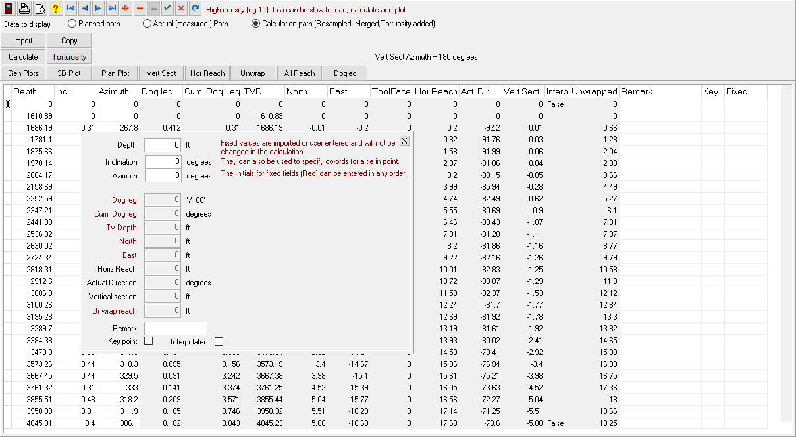

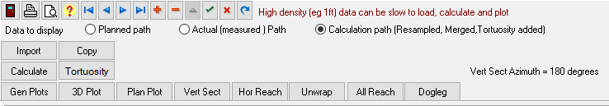

A set of radio buttons allows you to choose which of the 3 paths to display.

The **[Import]** button allows you to import data from a text file and the **[Copy]** button from another scenario. These are explained below.

Only Depth, Inclination and Azimuth are entered by the user or imported. The **[Calculate]** button is used to calculate the doglegs. North, East and TVD coordinates and various horizontal offsets are calculated using the minimum curvature method. During this calculation you will be prompted to enter the azimuth for the vertical section.

The **[Tortuosity]** button displays a dialog where you can define the parameters for adding tortuosity to various sections of the path.

The **[Gen Plots]** button displays a dialog where you can select the plots to produce and the curves to include. And the rest of the buttons on that row display those plots. Path plots can also be displayed from the **Plots tab** in the **Scenario** form or from the **Plot Selection** or **Path plots** options in the Graphics menu.

## Importing path data

After clicking on the import button, an Open file dialog will be displayed to select the text file to import.

If one is not selected, it can be selected from the form itself.

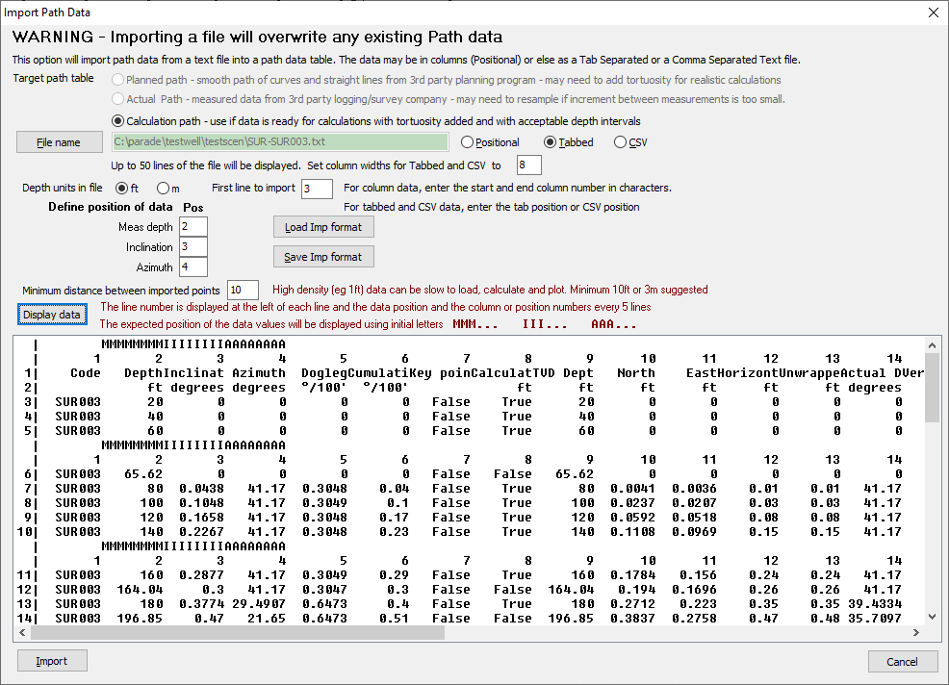

Select which of the 3 path types is being imported. If the data is ready for use in calculations, ie, it has a reasonable interval between readings and is either actual data or has had tortuosity applied then used the Calculation path. Otherwise use planned or actual as appropriate.

The [File name] button allows you to lookup and open a file, if you did not do it before the dialog opened. Once the file is opened the first 50 lines will be displayed in the scrolling display area below.

The type of text file is automatically detected.

You can set the column width in the display for Tab and CSV data so that it is easy to see which is which.

Specify the depth units.

Enter the first line to import to skip over any header lines in the file.

Next you enter the columns for each of the 3 fields to be imported. Only Depth, Inclination and Azimuth are imported and all other values recalculated. For Tab delimited and CSV files this is the tab or CSV position. For a plain text file where data is aligned using spaces, enter the start and end positions in characters.

You can [Save…] the values you have entered as an Import format and instead of entering the values manually, you can [Load…] values previously saved.

The display area shows the first 50 lines of the file, which are numbered, intersperse every 5 lines by 2 unnumbered lines. The top of these shows the columns that are assigned to each field, Using the First Character of the field labels, repeated. The second line shows the Tab or CSV positions or a character count for plain text. The [Display data] button will update this display, with the current column selections.

Click on **[Import]** to begin the process. Note that any existing data will be deleted and replaced by values from the file.

## Adding Tortuosity

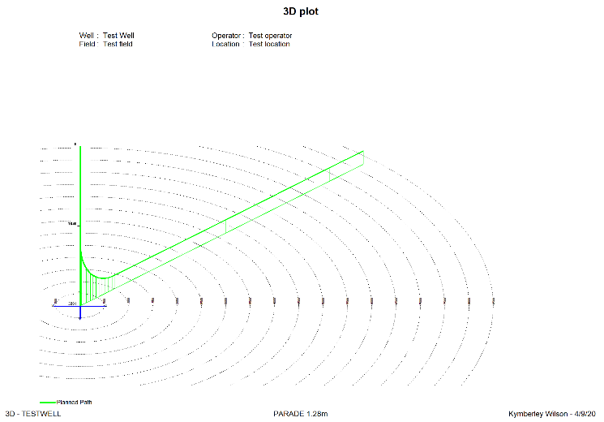A planned curve that consist of just straight and curved sections is unrealistic. In order to model a real well more accurately tortuosity needs to be added. This imitates the deviations of the real path from the ideal.

Parade uses a model in which the inclination and azimuth vary randomly from the ideal values. In addition, there is a bias applied to these variations back towards the ideal value which prevents the amended path wandering too far from the planned one. These new inclinations and azimuths are then used to calculate the new path – doglegs and position.

On the other hand, actual data can be very accurate but uses such small increments the data table has a large number of essentially similar values, which do not add to the accuracy of plots or calculations but slow both down. On a 300 dpi plot of a 10,000ft vertical well, each dot on a normal plot corresponds to around 4ft. On screen at 90dpi, a dot is about 12ft. So small increments in depth result in lines of less than 1 pixel being drawn. Hence the path can also be sampled at a higher increment.

The tortuosity dialog allows the well path to be divided into multiple sections and each section can have different corrections applied.

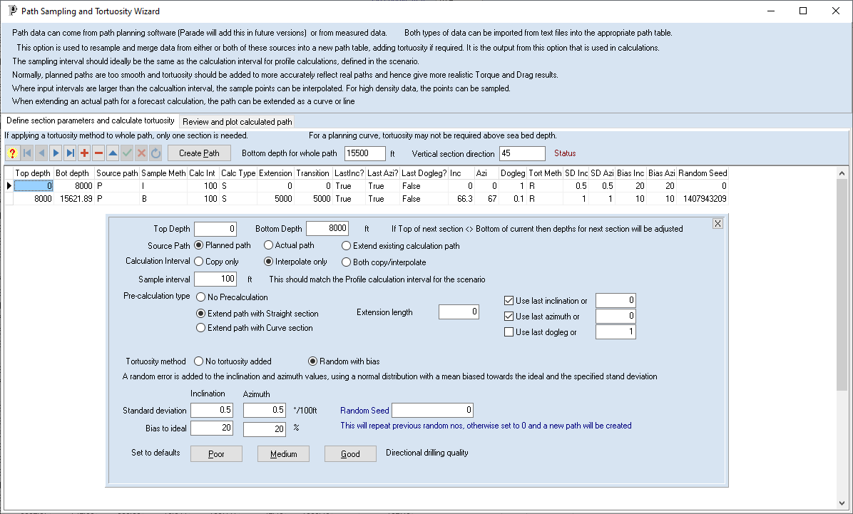

Each interval is defined by a top and bottom depth.

The source path is selected. The output path is always the Calculation path

There is a choice to include the original depths or only depths at multiple of the sample interval, or both and the sample interval is set. This should be related to the calculation interval in the scenario.

There is also an option to extend the source curve, prior to apply the tortuosity. This ensures that it is applied to points along the extended line incrementally rather than as a single correction applied to one large interval, which does not allow the bias corrections to be applied.

There are 2 choices for the Tortuosity method – None and Random with bias.

The random with bias applies an error to each inclination and azimuth value using a normal distribution with the user entered Standard deviation and bias for each.

The standard deviation figure determines how much the inclination and azimuth vary at each step. These are generally 1 degree per 100ft/30m or less. The bias to ideal, as a % determines the correction at each step these are generally 10% or higher. There are buttons which select pre-set values that you can use.

The random seed is the starting point for the random number generator. If 0 is entered a new seed will be created. However, if you want to compare different parameters you should use the same seed each time.

If you are sampling an actual path with high density data, select Interpolate only and the No Tortuosity Added option. For adding tortuosity to a planned path, select the Random with bias option.

Once the parameters have been entered for each section Click on [Create Path]

In the example, the first section only includes multiple of 100ft, while the bottom section includes the existing points and the end point. The first section has a “Good” set of parameters and the bottom has a “Poor” set.

Both are extended with straight sections, with the top section adding points to 8000ft and the bottom to 15621.89.

The path is calculated and the Review and plot tab displayed

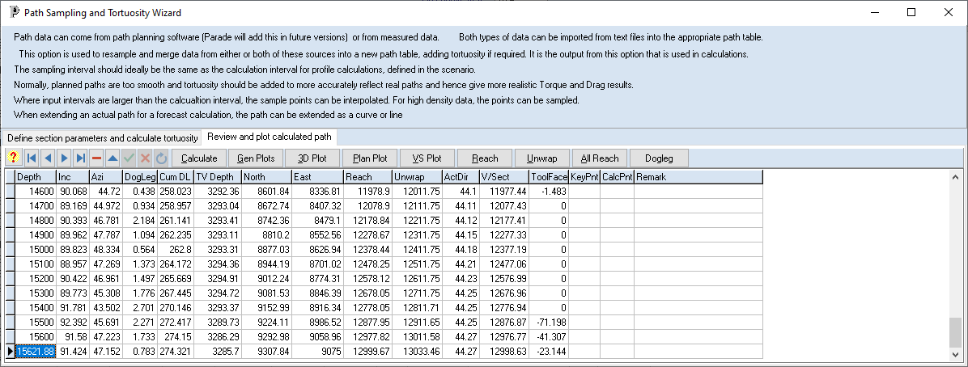

You can generate plots and display them.

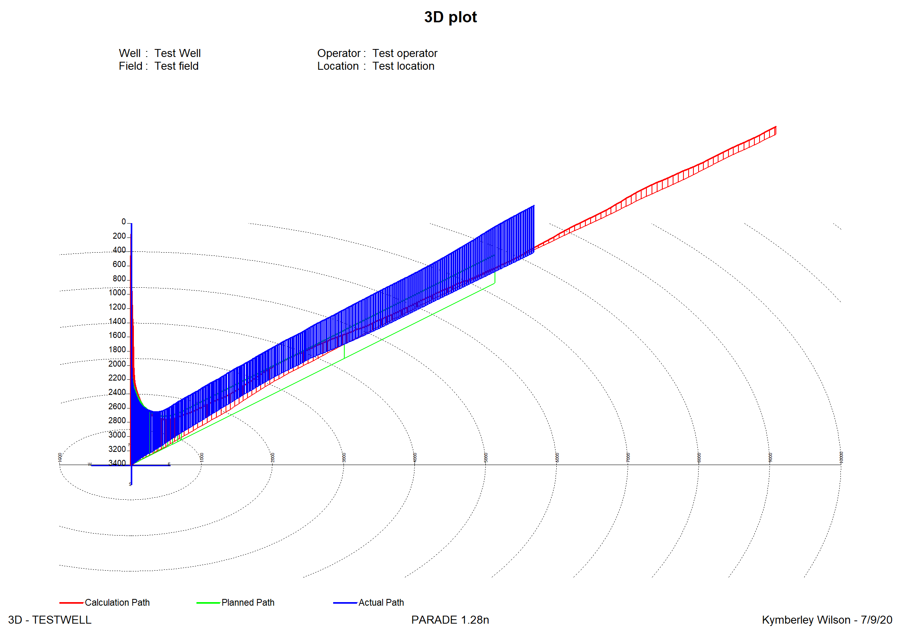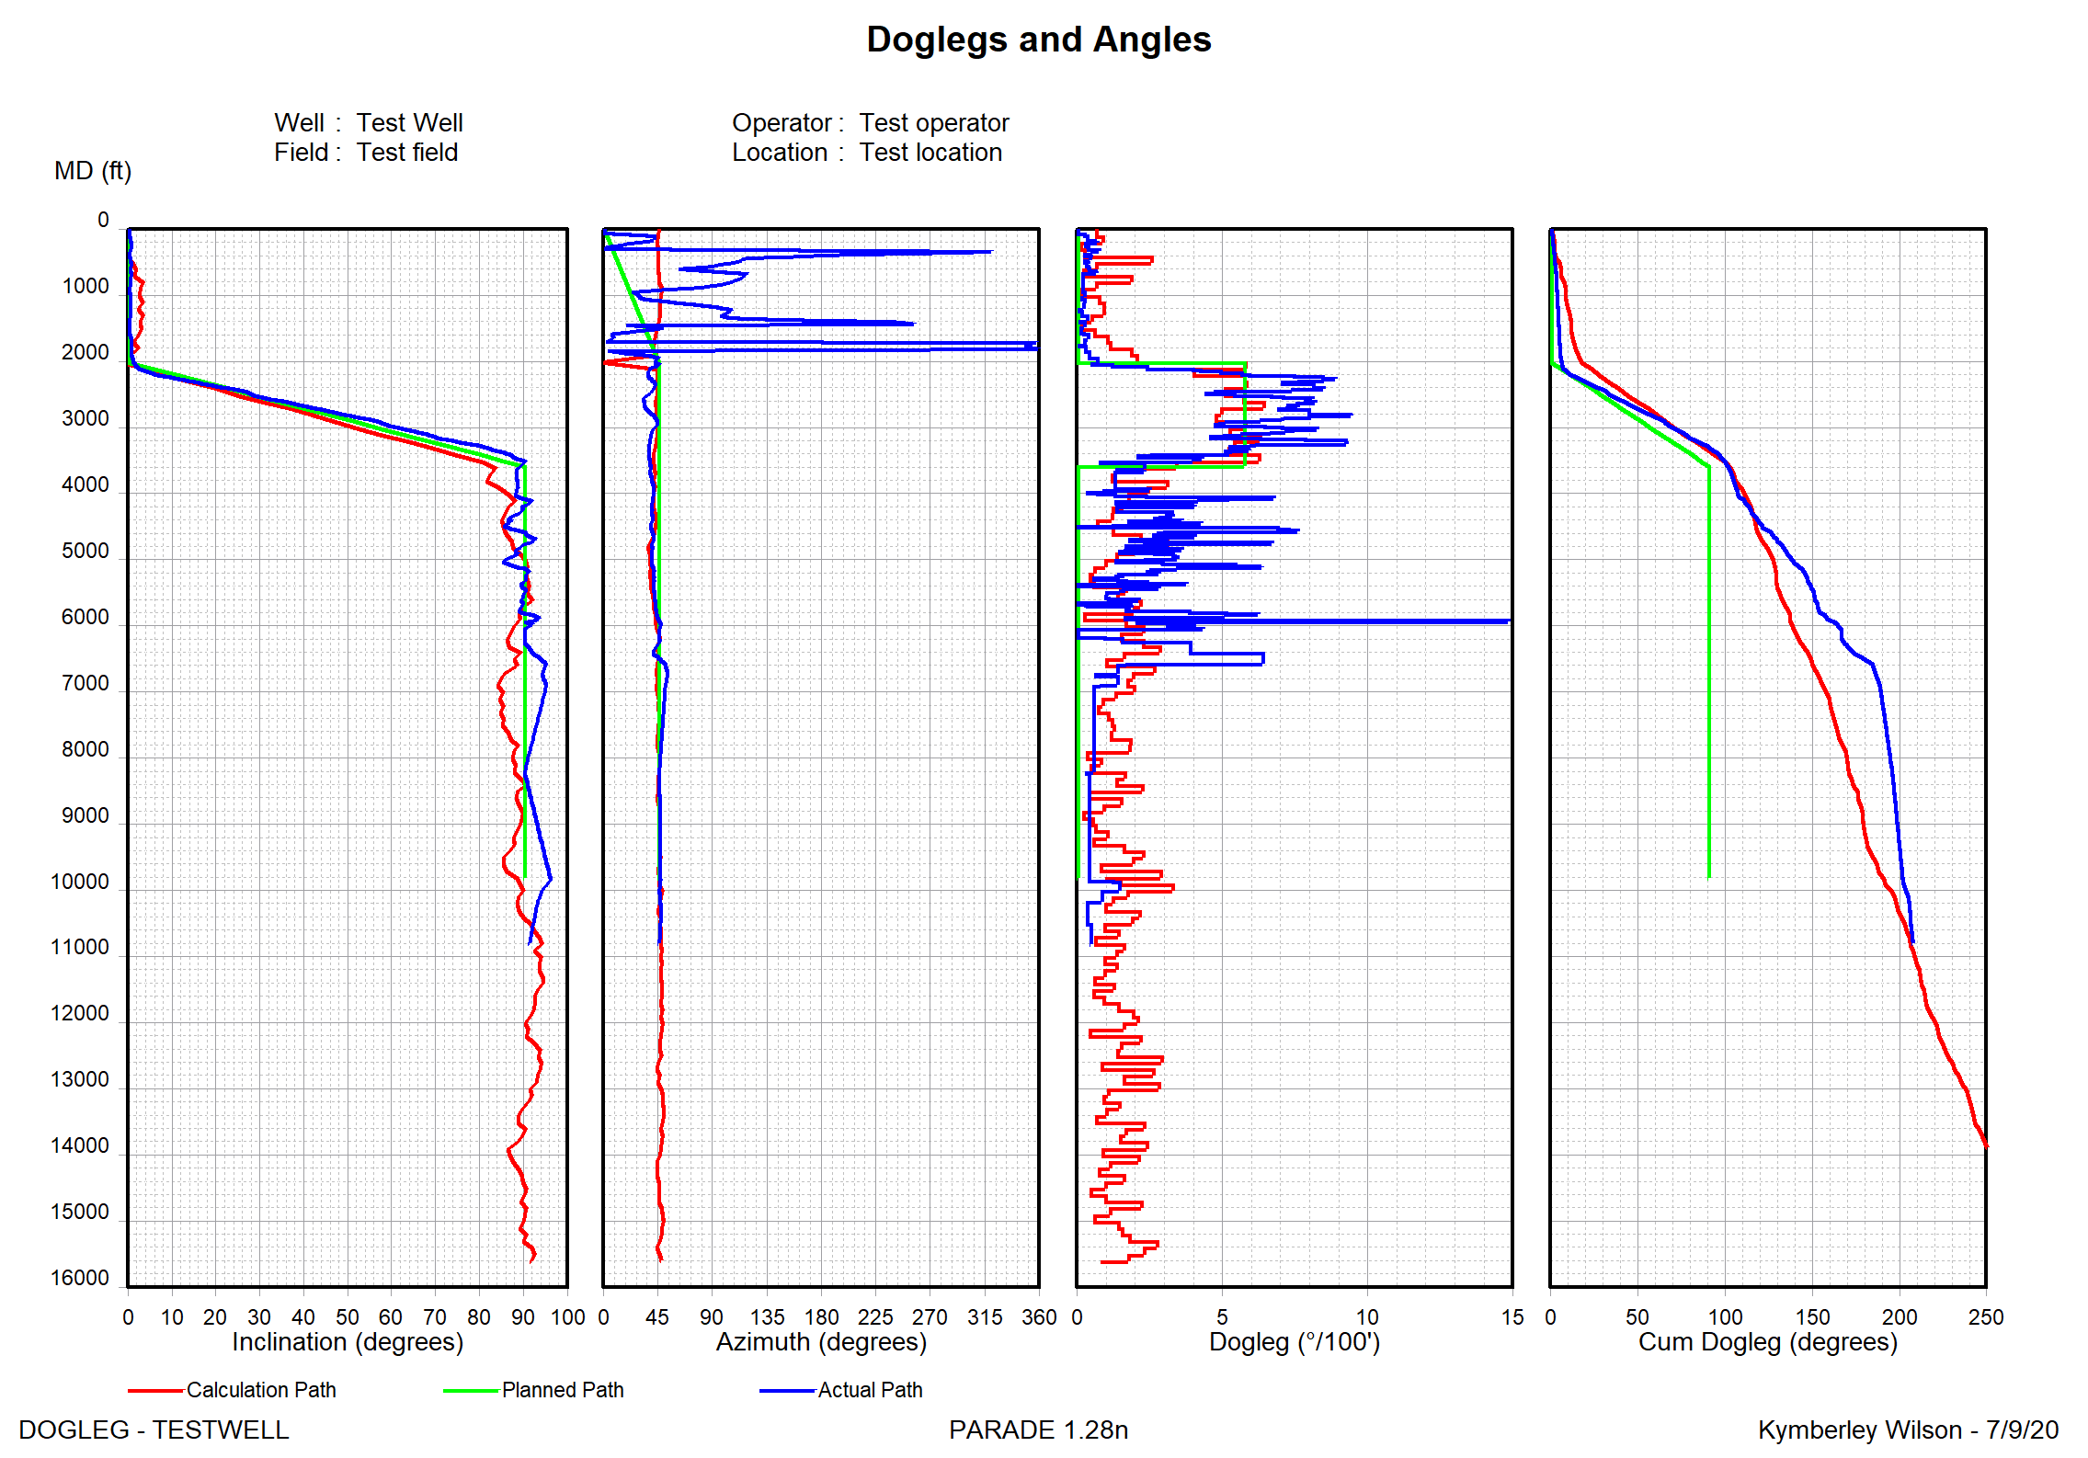

These plots show that the calculation path has much more tortuosity than the planned path. The actual path is also shown. You would not expect a match between the calculated and actual paths in the details of inclination but cumulative doglegs show an overall agreement.

# String and Accessories

The drill or casing string is defined in this option and it consists of items from the bottom of the string upwards. The first item is usually the Bit or the Casing shoe

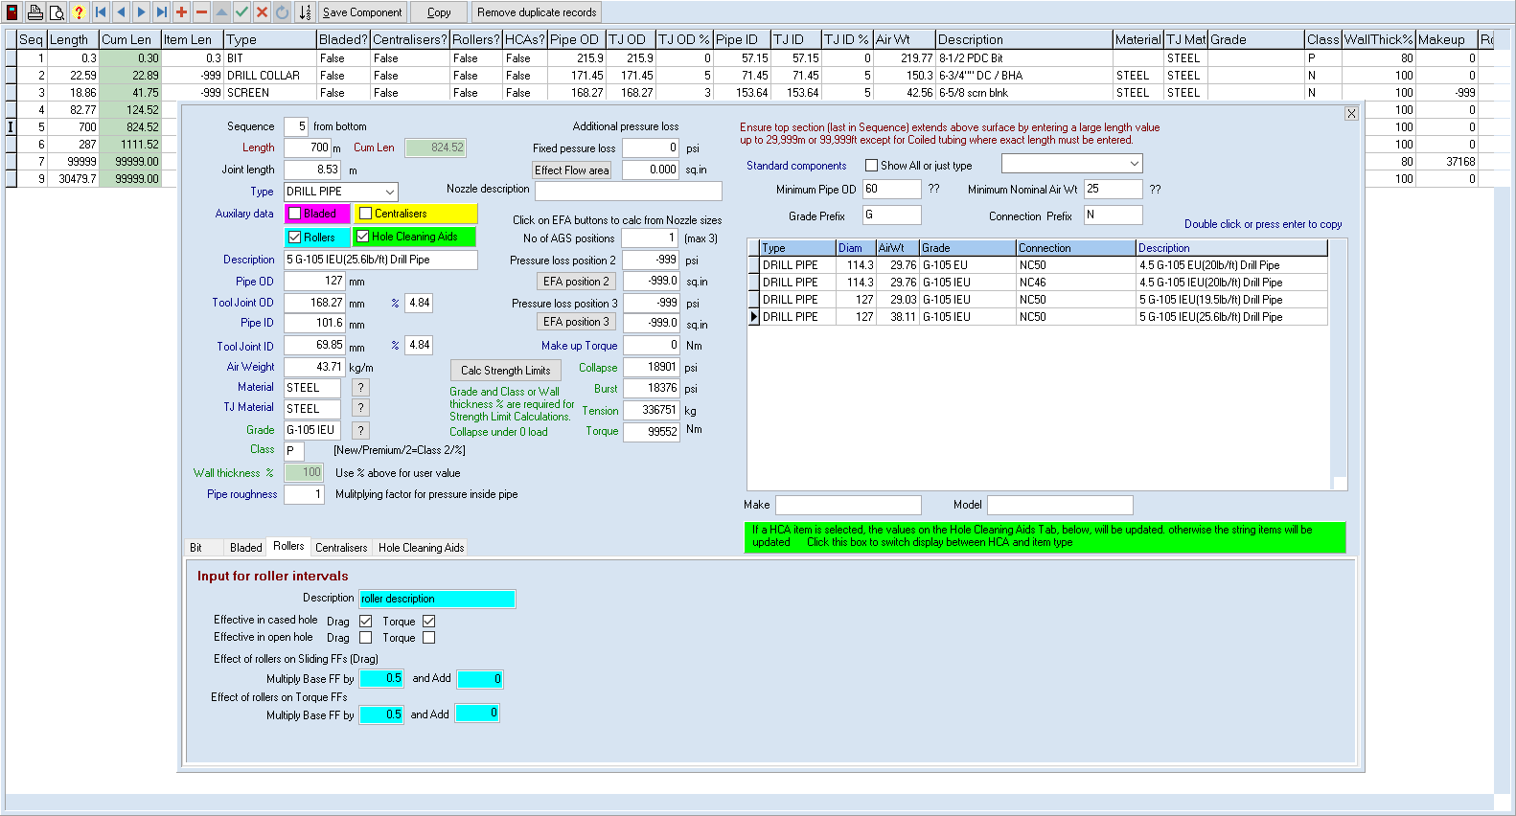

Each item has a length and the cumulative length is calculated automatically. The last item in the string – Drill pipe, Tubing or Casing does not need to be calculated exactly. Enter a large number sufficient to ensure the string length is greater than the expected TD and the program will use as much of that item as required to reach the surface. A value of 99999ft or 39999m with ensure this happens.

For each item, select a type and indicate if it is Bladed) or has Rollers or Centralisers Attached or Hole Cleaning Aids (HCAs) inserted at intervals. Hence 2 sections of identical drill pipe would require a separate entry in this table, if one had centralisers and the other did not.

The bottom of the screen has a tabbed notebook and different tabs will be selected based on the type and accessories selected for each item.

The basic physical parameters including diameters and weight, material types grade and class are entered, with different values entered for the pipe itself and the tool joints.

Hydraulics data such as Effective flow area of nozzles and any fixed pressure losses in addition to the inner diameter flow-based pressure loss can be entered. For an Adjustable Gauge Sleeve, these values can be entered for an extra 2 positions and the improvement factor for Hole Cleaning aids can also be entered.

String Strength limits can also be calculated.

For the bit, the Junk Slot Area (JSA) needs to be defined. This will also have an Effect Flow area from the nozzles.

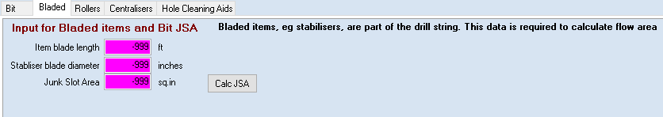For bladed items, addition fields are used to record the blade parameters and the Junk slot area, the area between the blades.

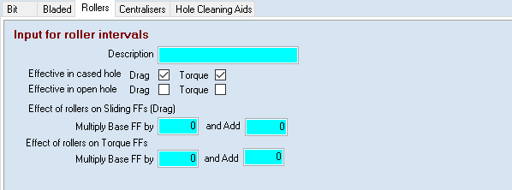For Rollers, indicate whether they are effective in Cased and/or Open hole and how they impact the Friction factors.

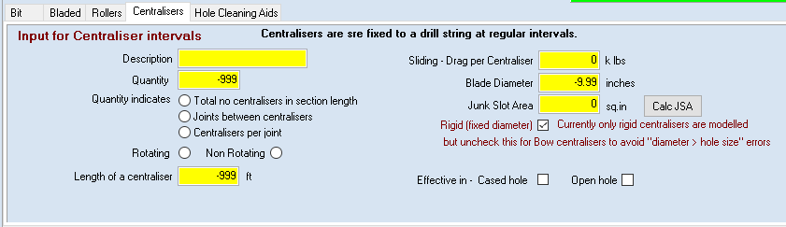For Centralisers, the quantity is defined either as the total in the section or via spacing relative to joints. These require the joint length to be defined in the scenario.

Physical values, similar to the bladed items, plus the drag per centraliser are entered. The drag is added to the P/U tension and subtracted from the S/O tension.

Where the JSA is not known it can be calculated in a popup dialog.

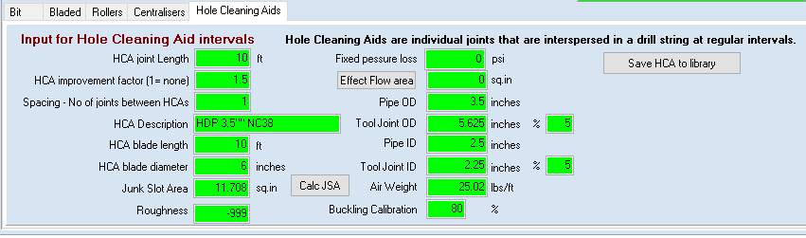

Hole cleaning aids are separate items that are inserted into string section are regular intervals. These require most of the input parameters as for a string section, plus a spacing and a flow improvement factor.

A Junk slot area can be calculated if it is not known by clicking on the [Calc JSA] next to the field.

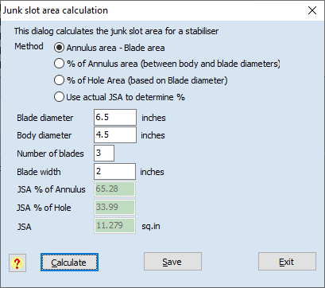 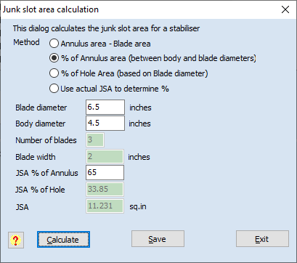

There are a number of alternatives for this calculation and each has a different set of input parameters.

The [Calculate] button then starts the process to calculate the other parameters.

[Save] will save the JSA to the string item.

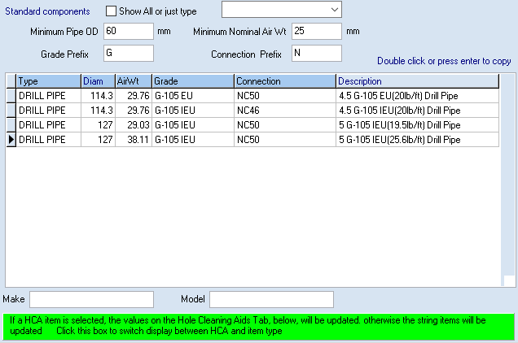

Rather than enter each item’s values manually you can select an item from the String Component library. This can be filtered by the Type and is selected by double clicking on a line or by highlighting a line and pressing enter. When setting up the library it is useful to use a consistent set of codes which would include a prefix for the type, then a size indicator, eg D45….. for 4 ½” drill pipe.

By default, only the selected type will be displayed in the table, and will be automatically updated when a new string item is selected.

If the type is selected as HCA, then selecting a record will up date the values on the HCA tab rather than in the main area. Click on the green box to display the HCA items.

In addition, further restrictions in the items listed can be imposed by entering the Pipe OD, Nominal Air weight, grade and connection criteria. These are all minimums so exact values are not required.

Since the sequence is defined by the sequence number, a decimal value can be entered, eg to insert a new component above the bit use Seq 1.5. The [123] button will then re-sequence these as whole numbers.

If you have entered a new string component for the first time and want to re-use it, us the [Save component] button. You will need to enter a code for the new component. The HCA tab has a similar button to save a HCA to the library.

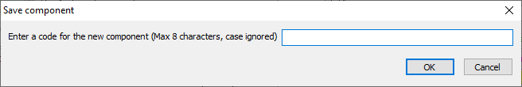

You can also [Copy] a string from another scenario, either from the current or a different well as described above.

# Hole Profile

The hole profile usually contains just a few items to define the internal diameter of the hole. These usually consist of the previous casing string and the open hole. However, where washouts or squeezing formations are expected, additional intervals can be defined.

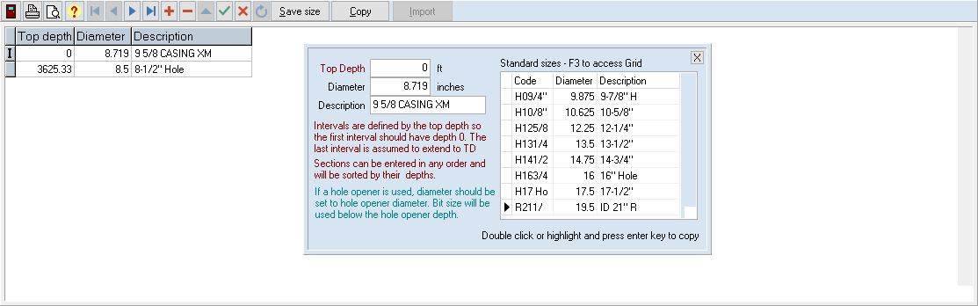

Each section is defined by its Top depth and internal diameter. The last section is presumed to continue to the bottom of the hole.

In a similar way to the string table, items can be copied from the Hole component library and entered values saved as a new library item.

The hole profile can also be copied from another scenario.

# Mud Variation

In many scenarios it may be possible to model mud by a single mud weight and rheology (ie a set of 6 FANN readings at different rpms).

However, mud properties may vary for a number of reasons.

While drilling, mud may be circulated out at a particular depth. Likewise, during a trip or casing run.

Mud properties may vary due to temperature or pressure and so change as the mud circulates while drilling.

If these circumstances occur check the box next to the green button and use the button to display the screen to define values.

## Mud program

The mud program table defines the changes to the mud used or its properties, as measured at surface during the drilling phase.

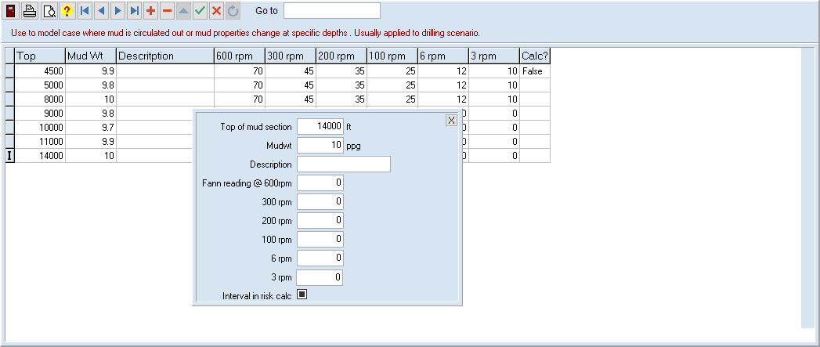

The **Top depth** defines the depths from which the new mud is used. If the first record has a top>0 then the base mud is used above that depth.

The new **Mud weight and Rheology** are entered.

If the mud risk calculation is to apply over this section, tick the box.

## Annulus Mud Weight Profile

This defines the mud profile during a trip. This could indicate a mud circulation part way out of or into the hole.

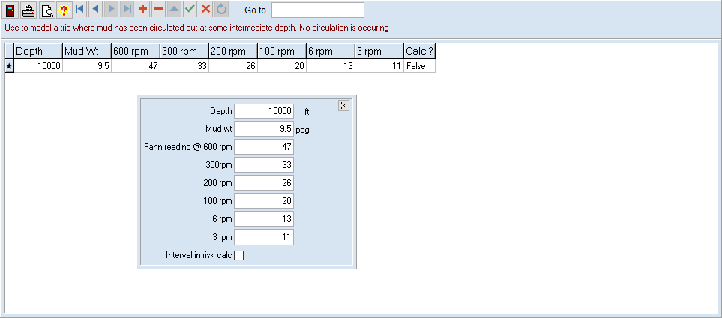

The data is the same as for a mud program but in this case the **Top depth** represents the depth in an existing hole where the mud weight or rheology changes.

## Pipe Mud Weight Profile

This is used to model a drill string or casing string that has different layers of mud. In particular it can be used for modelling floated casing.

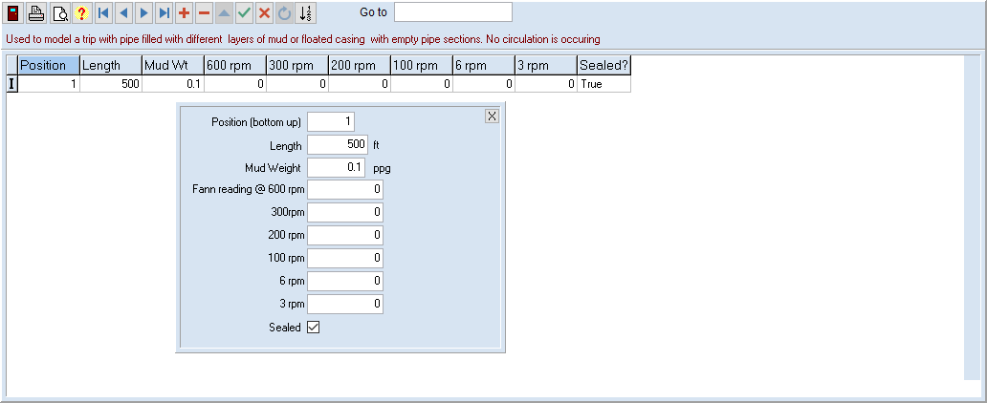

Since the depth of the column varies with bit depth, the sections are defined by a **position** and a **length**.

Any mud above the last section defined is set to the base mud for the scenario.

Once again, the mud weight and rheology are entered.

In this example, the bottom 500 ft is filled with air, with a seal at the top.

## Circulating profiles

Circulating profiles are used to model the changes to a mud that occur during circulation (of the same base mud). These are often due to pressure and temperature effects on the mud.

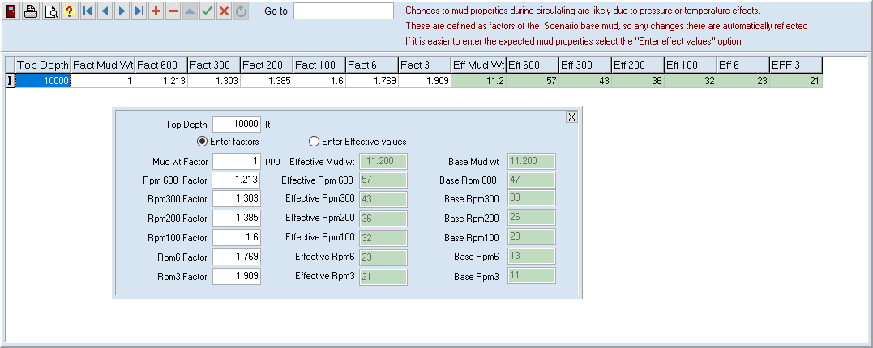

Both the annulus and fill circulating profiles are defined by the Top depth, since the changes are related to the hole depth, wherever the bit may be.

The Top Depth defines where the changed values occur.

Unlike the other mud table, the circulating profiles define the mud properties relative to the surface. That way if you change the surface values, the temperature/pressure factors apply to the new properties and you don’t need to change each one separately.

However, since it is often easier to enter the expected values directly, you can choose between enter the factors, which will display the effective properties, or entering the properties which will calculate the factors.

## Mud columns

In Surge and swab calculations, mud columns are similar to the Mud program, in that they represent mud changes that occur when the bit is at different depths and most likely represent circulation to a new mud type

The definition screen is essentially the same as for the mud program.

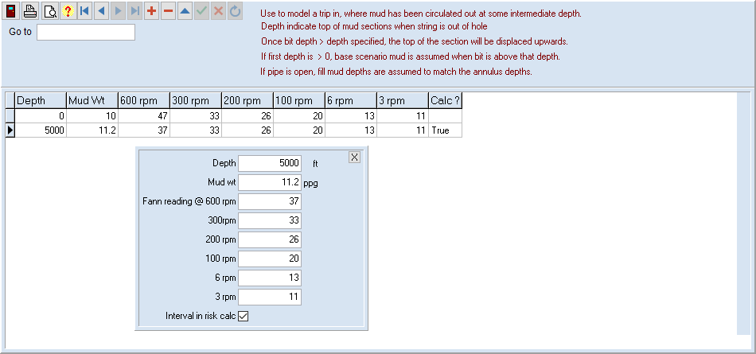Separate mud columns are defined for tripping out (Swab) and tripping in/running casing (Surge).

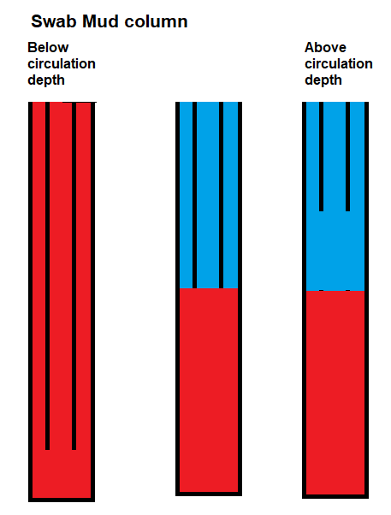It is assumed that, for open pipe, the mud properties are the same inside and outside the pipe, and that these apply when the bit is at a depth covered by the section. When the bit is in a different section, those values are applied.

For a trip out this would correspond the having the initial mud through the hole and pipe from TD up to a circulation depth. At that point the mud in the pipe and annulus is replaced by a different mud type, which applies to calculations from that depth upwards. Hence the swab mud column defines the sections as they would be once the string is out of the hole.

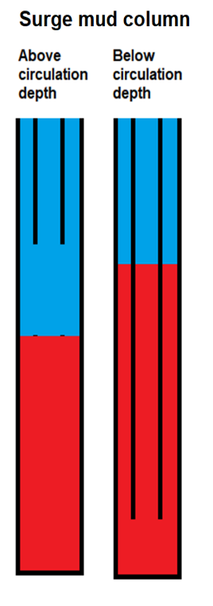For a trip in, the surge mud column defines the initial mud column, before the string enters the hole. In practice, this is the mud column that remains after the previous trip out. Such a mud column can be created, even without circulation, if the pipe and annulus are filled with a different mud type during the previous trip out. Ie the Swab fill profile described below.

As the string goes deeper into the hole, the mud displaced by the string forces the top of the mud column sections to rise.

For open pipe, it is assumed that these tops will be the same inside and outside the pipe for the open pipe case.

If the top record has a depth >0, Base mud is assumed to apply to the surface.

If the pipe is closed, mud displaced by the string raises the annulus level only.

The mud inside the string is assumed to be base mud.

If there is no circulation during a trip and this table is empty the base mud is used for the surface properties at all depths.

## Mud Depth Effects

Also used in Surge and Swab, Mud Depth Effects define the changes in mud properties for a fixed bit depth at different depths in the hole.

They are used to model changes due to pressure and temperature.

Like the circulating profiles for Hydraulics calculations, the mud values for a section are defined as factors to be applied to the base mud, rather than actual mud values. This allows the base mud values to change and be reflected by the Depth effects, with out need to edit each Depth effect record to reflect the changes.

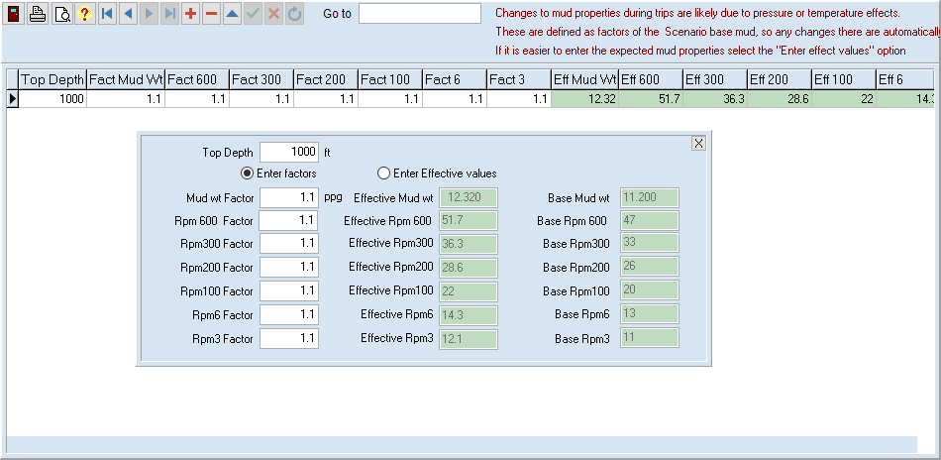

If the top record has a depth >0, Base mud is assumed to apply to the surface.

# Friction Factor Profile

The base FF profile is required for Torque and Drag calculations.

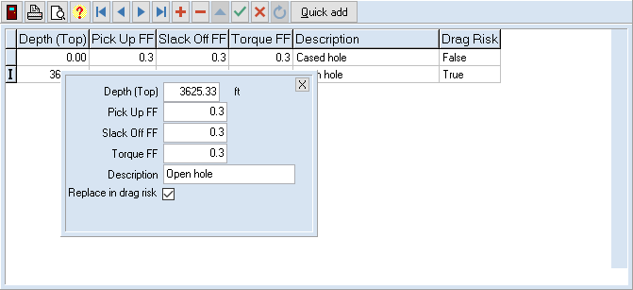

The sections usually correspond to the open and case hole sections.

These are defined by their top depths, with the last section assumed to apply to TD.

The 3 types of Friction factor are entered

A description can be entered and you can indicate if this section is to have variable values in the XFVF risk calculations. The open hole sections almost always have this checked. If a Cased hole FF is back calculated from Hookloads at the Casing shoe, or known from another well, then this may be unchecked.

The [Quick add] button uses a single FF for all values in 2 sections, with the first being open hole with risk turned off and the second being open hole with risk turned on. The scenario casing depth is the top of the open hole interval. This will replace existing data.

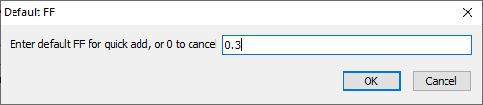

# Reaming Intervals

In planning, you can turn on or off reaming calculations for the Drag risk calculation

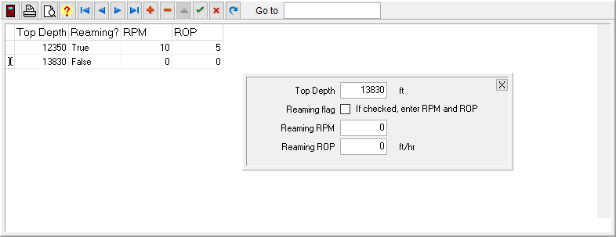

Define the top of the interval and whether reaming is occurring.

If it is, enter the RPM and ROP values.

To turn reaming off, you need a second entry at the bottom of the reaming interval.

Reaming intervals are only applied in open hole.

This example has reaming occurring between 12350 and 13830 ft

This data is only used to add reaming intervals to Planning Drag Risk calculations

Reaming is assumed to be occurring at all depths for the Planning Reaming Risk calculations and is used in Analysis Drag Risk calculations when the measured data indicates reaming is occurring at that depth.

You can see the difference when reaming intervals are used in the right-hand plot.

